## Customizing Sites using Web Parts and XSLT

**Lab Time**: 45 minutes

**Lab Folder**: C:\Student\Modules\WebParts\Lab

**Lab Overview**: In this lab you will get hands-on experience working with Web parts on a Publishing site. There are many Web parts available on publishing sites to help you create user experiences that roll-up information, pull navigation from the site collection and present summarized information. This lab will explore a few options.

### Lab Setup: Master Page Change and Content Builder

Before starting this lab, please change the site and system pages back to the austin master and run the script that will build out the Press Release section.

1. Go to Wingtip’s publishing sites (<http://www.wingtip.com>) in your browser.
2. **In your web browser, go to Site Settings menu and select Site Settings.**
3. **On the Site Settings page, select Master Page under Look and Feel.**
4. Change the site master page settings to use the **portland** master. Be sure to check the checkbox below the master page selector to reset all subsites to use the new master pages settings. **Select OK**.
5. On your computer, browse to the lab folder for this lab
6. Find **Create-PublishingPages.ps1**, **right click** on the file and select **Run with PowerShell**.

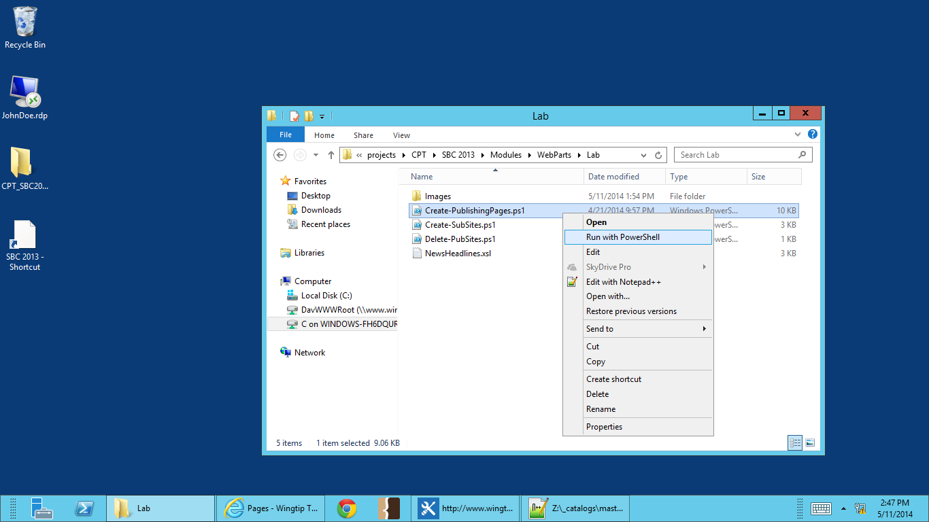

1. If a Securty Warning dialogue box pops us, select **Open** to continue.
2. Next, a PowerShell Administrator Window will open. Press **Y** and **Enter** to run the script.

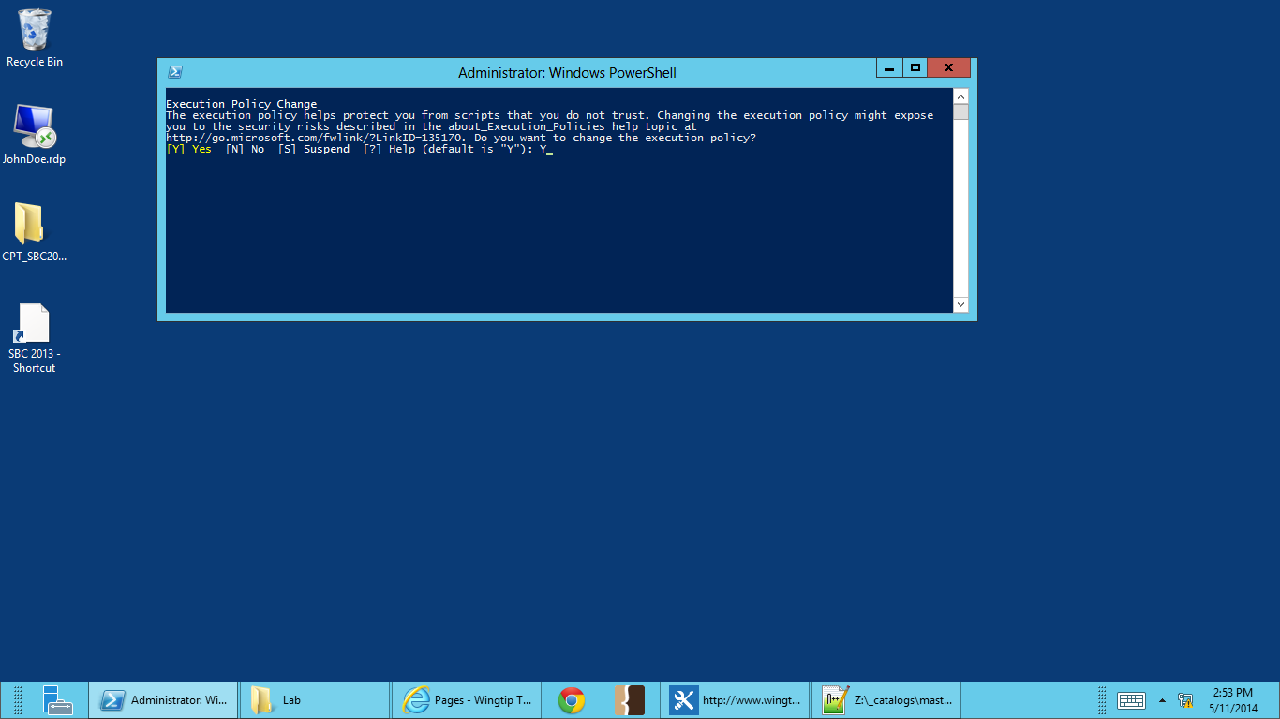

1. After the script is done running, go back to <http://www.wingtip.com>. You should see in the left navigation that the **Press Release** site has now been added.

### Exercise 1: Configure the Summary Links Web Part

In this exercise you will configure the out of the box Summary Links Web part. This web part makes it easy for content authors to add links to content both inside and outside the site collection.

1. Go to the Wingtip Products page in the publishing sites (<http://www.wingtip.com>) in your browser.
2. Go to **Site Actions -> Edit Page**.
3. Select **Add a Web Part** in the web part zone directly under the content.

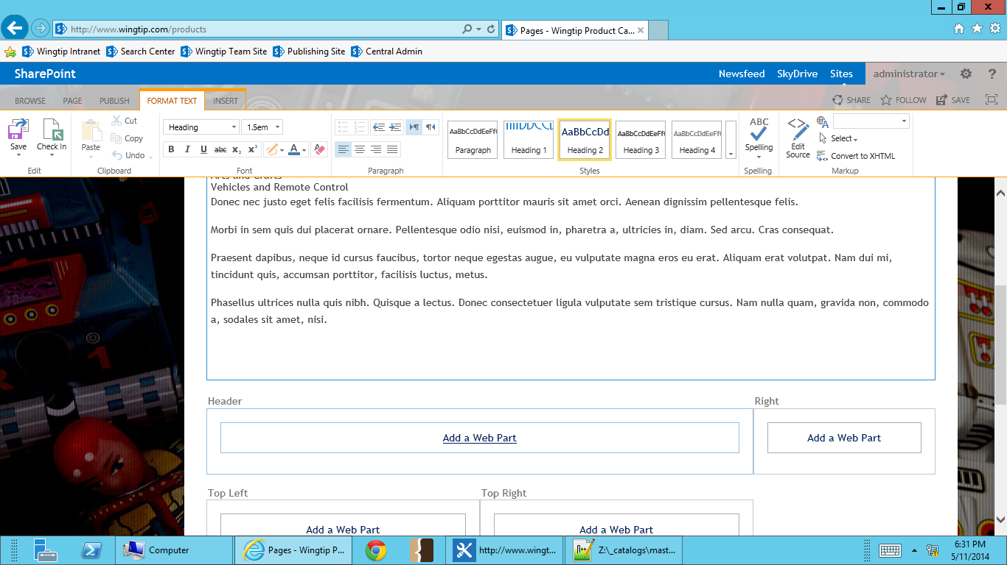

1. Click the **Content Rollup** folder in the **Categories** pane. Select the **Summary Links** Web part from the **Parts** pane. Ensure the **Add part to:** drop down indicates the **Header**. Click **Add** to insert the Web part.

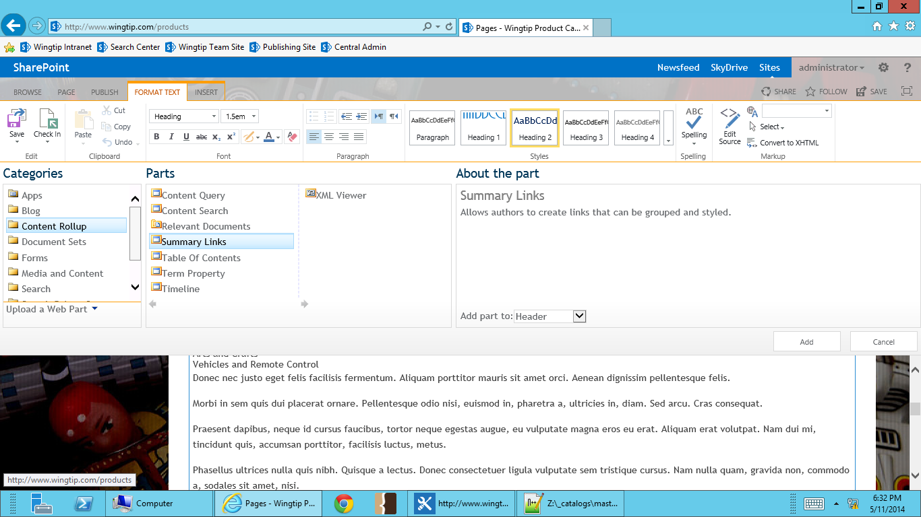

1. In the Summary Links Web Part, select **New Group**.

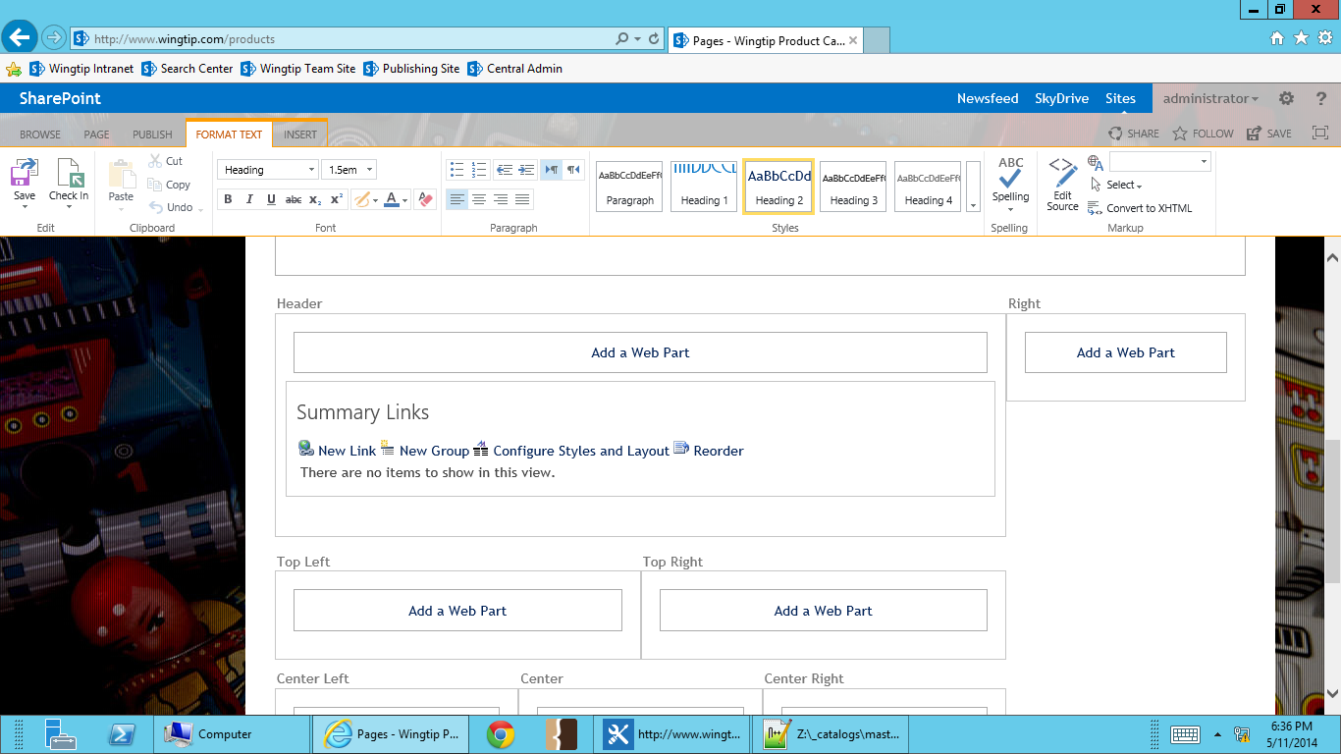

1. Call the new group **Wingtip Product Categories**. Select **OK**.

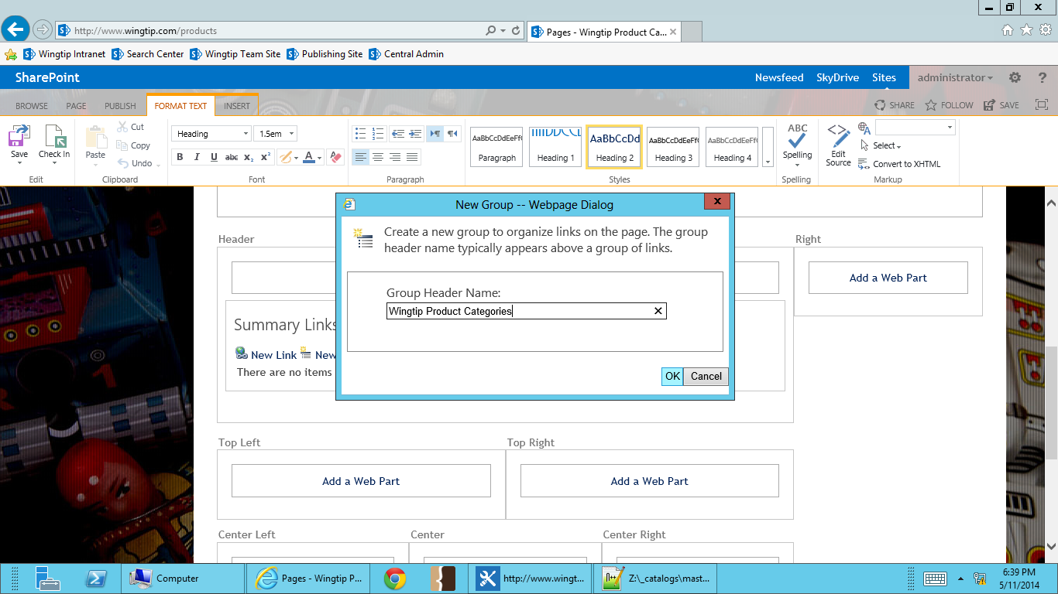

1. In the Summary Links Web Part, select **New Link**.

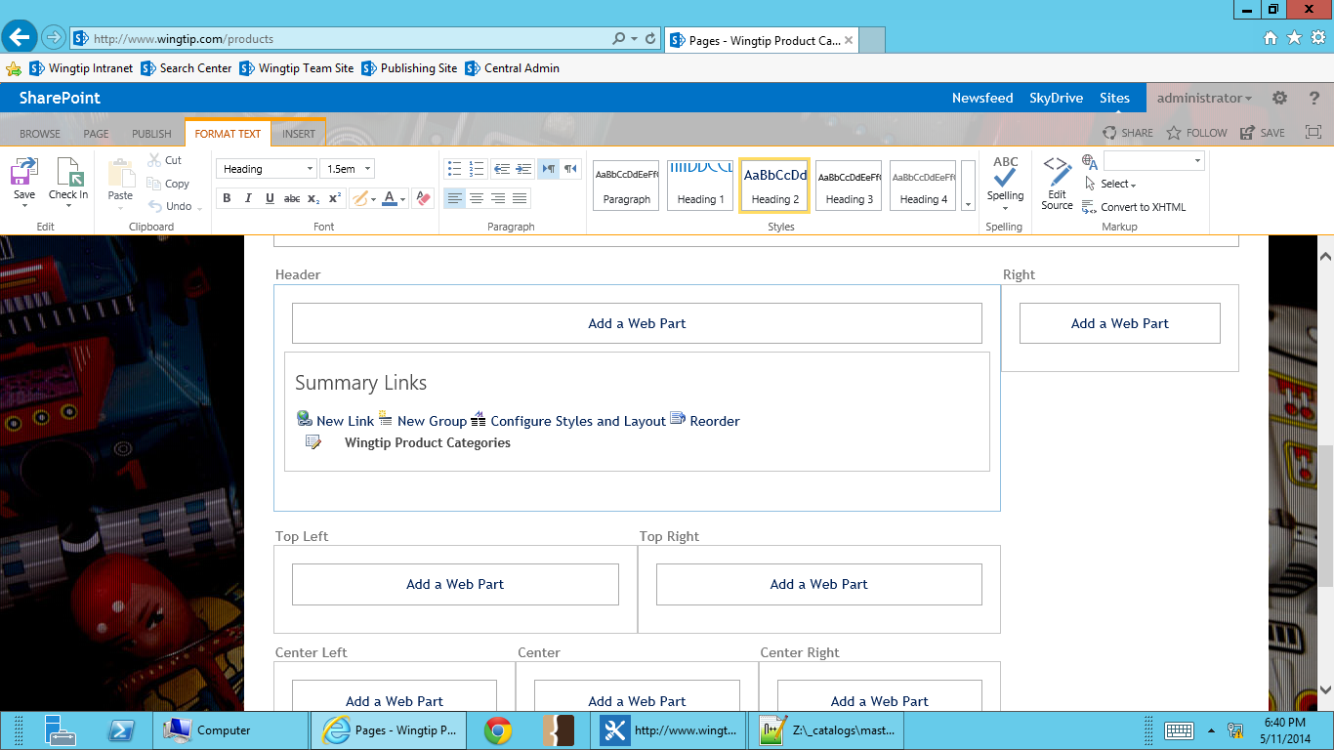

1. Create a link for Action Figures.
   1. **Title**: Action Figures
   2. **Description**: View Wingtip’s large selection of action figures.
   3. **Link URL**: /Products/Pages/actionfigures.aspx
   4. **Style**: Title and description
   5. Select **OK**.

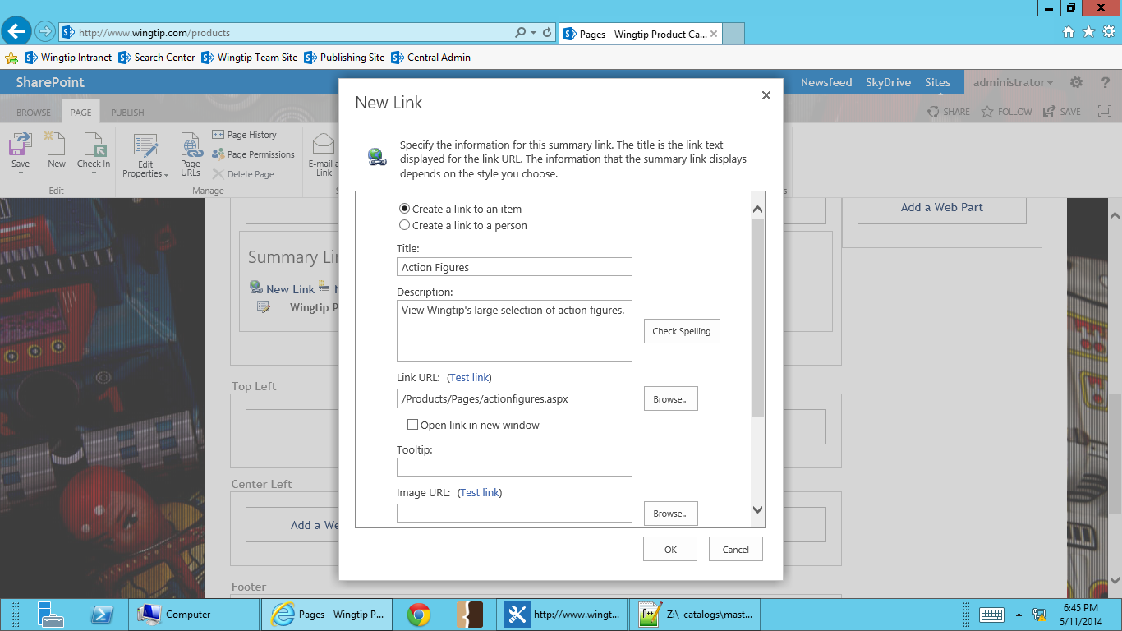 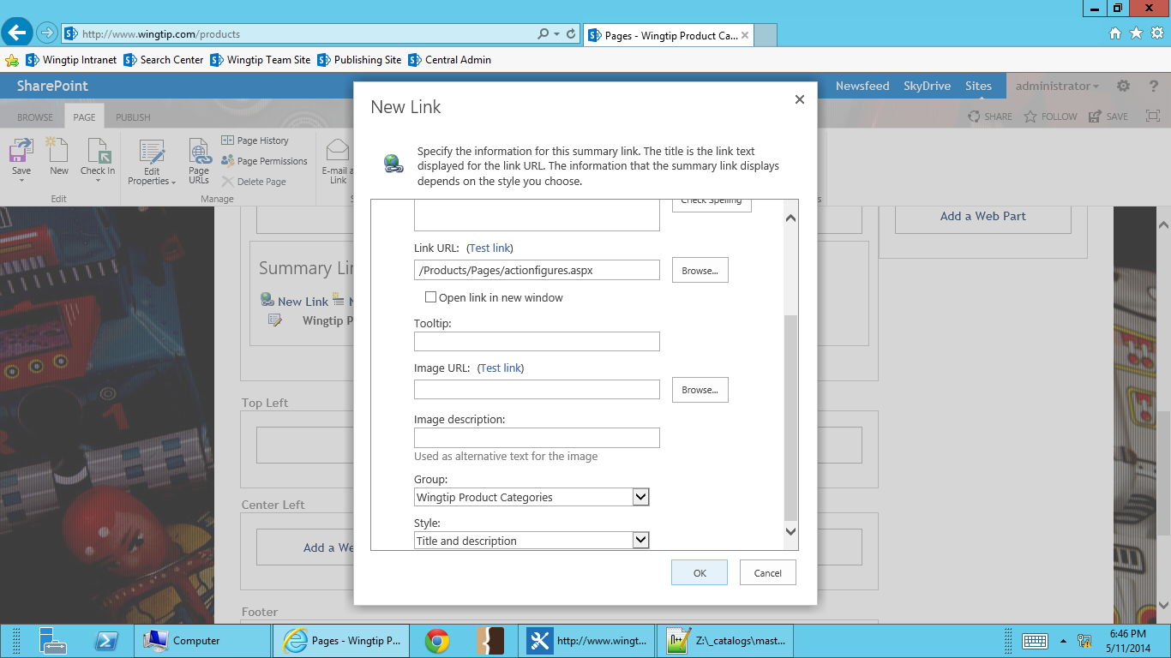

1. Create a link for Arts and Crafts.
   1. **Title**: Arts and Crafts
   2. **Description**: Wingtip has everything for all your arts and crafts needs.
   3. **Link URL**: /Products/Pages/artsandcrafts.aspx
   4. **Style**: Title and description
   5. Select **OK**.
2. Create a link for Vehicles and RC.
   1. **Title**: Vehicles and RC
   2. **Description**: Planes, trains, automobiles and much more!
   3. **Link URL**: /Products/Pages/vehiclesandrc.aspx
   4. **Style**: Title and description
   5. Select **OK**.
3. Check in the page.

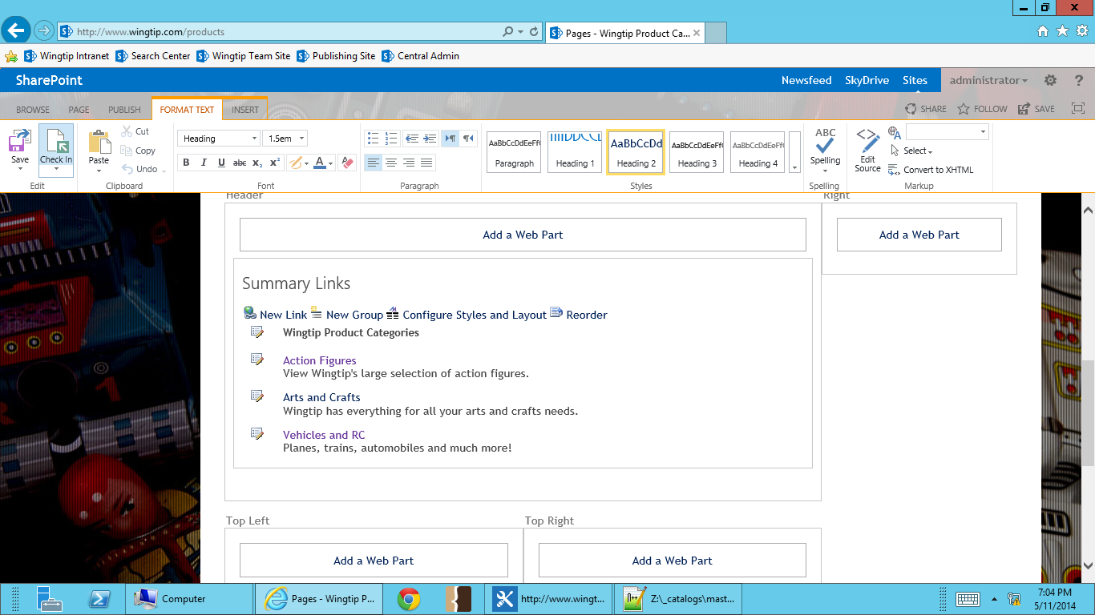

1. You should now see your newly configured summary links web part.

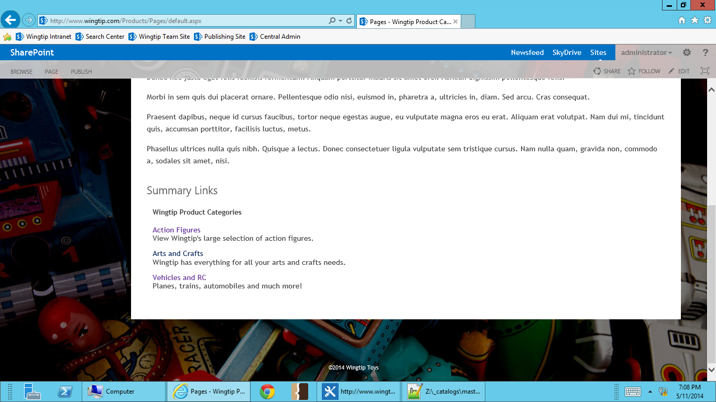

By default, web parts are set to display their title. Since we don’t want the name of the web part to show on the page, we must update the summary links settings to not display it.

1. Go to **Site Actions -> Edit Page**.
2. Scroll down to the summary links web part. Move your cursor to the top right corner of the web part. A dropdown arrow for the web part menu will appear. **Select the down arrow**, and from the menu select **Edit Web Part**.

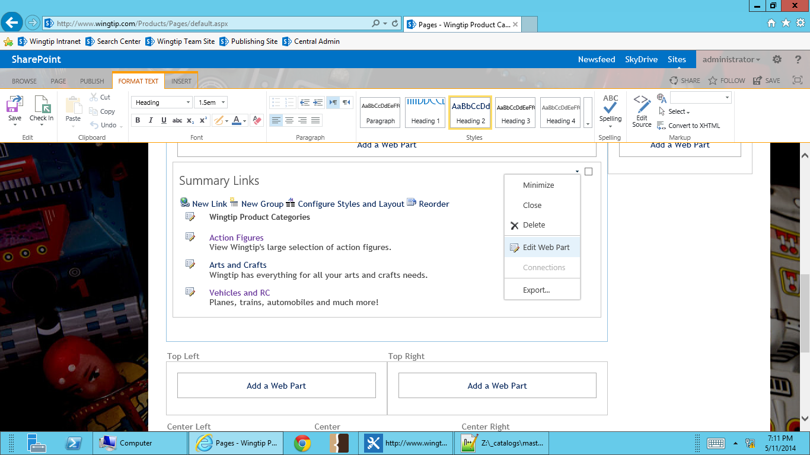

1. In the summary links web part edit options, select **Appearance**.
2. Under Chrome Type, change from Title Only to **None**. Select **OK**.

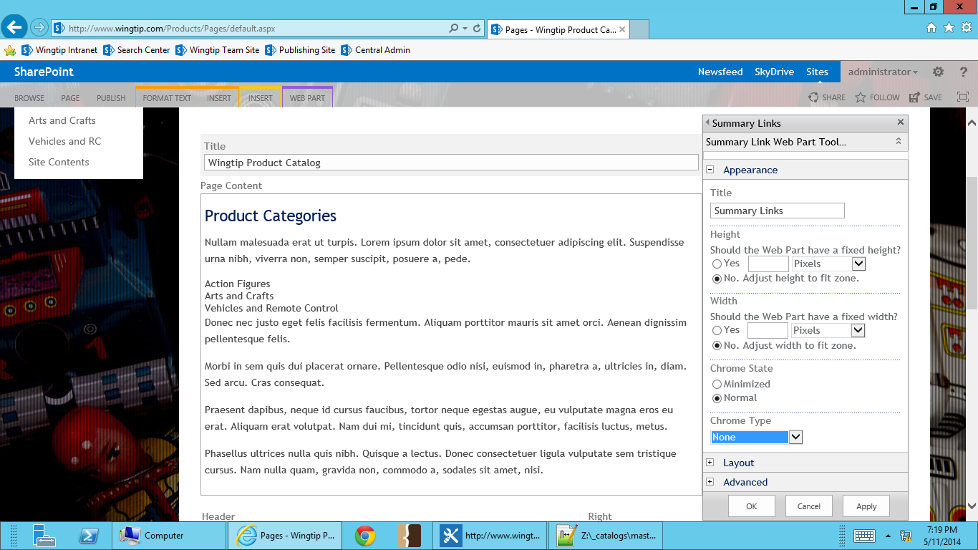

1. **Check In** the page.
2. You’ll see that the web part title is no longer showing.

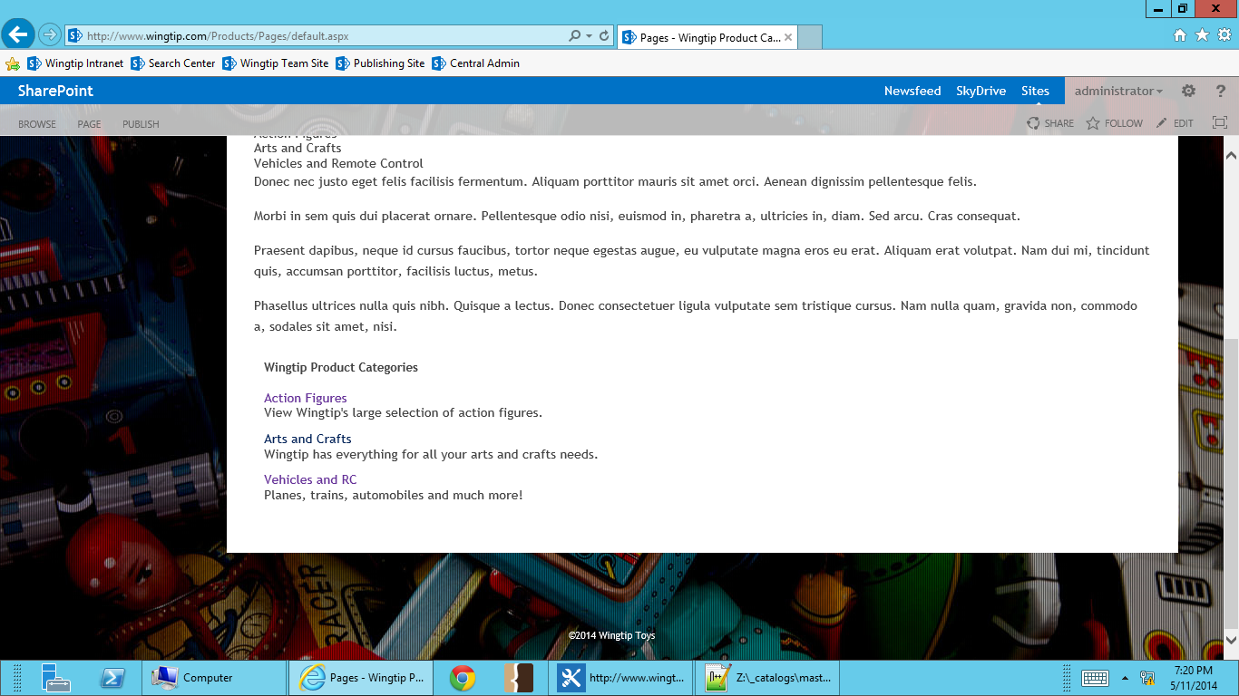

### Exercise 2: Adding Web Parts to a Publishing Site

In this exercise you will add a Table of Contents Web part to your publishing page and explore the various options available for configuring the web part.

1. Go to the Wingtip Products page in the publishing sites (<http://www.wingtip.com>) in your browser.
2. On the Home Page click **Site Actions | Edit Page**.
3. In the **Header** Web part zone, click **Add a Web Part**.
4. Click the **Content Rollup** folder in the **Categories** pane. Select the **Table of Contents** Web part from the **Parts** pane. Ensure the **Add part to:** drop down indicates the **Top Left**. Click **Add** to insert the Web part.

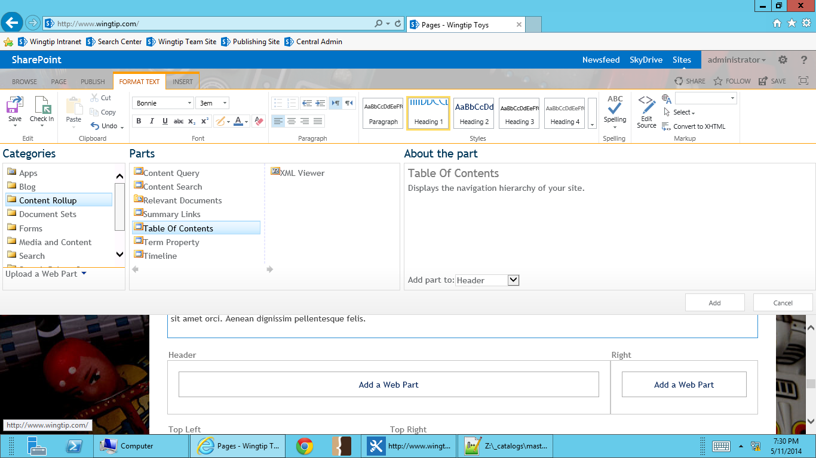

1. You should now see the **Table of Contents** Web part on the page.

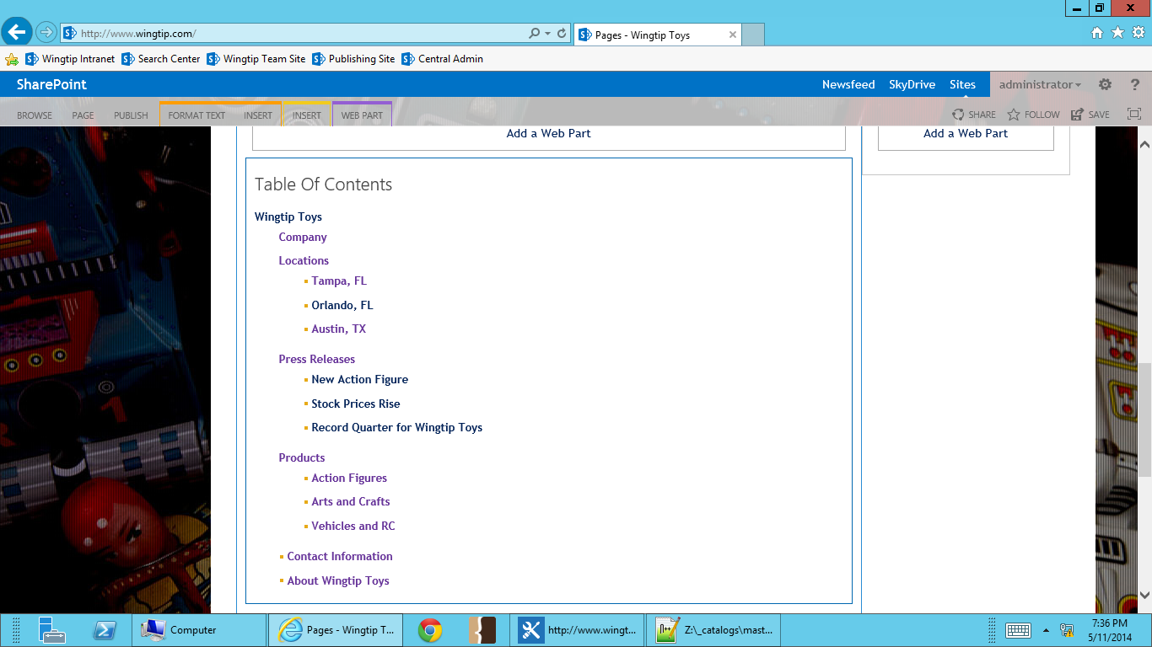

The Table of Contents Web part uses the settings from the current site for Navigation. New features of site navigation can prevent the web part from working the way you expect. You can change the Navigation settings if you understand that this will cause other changes as well.

1. The Table of Contents Web part is showing the whole web site. You can change this behavior in the Table of Contents web part options. For this exercise, we’ll hide the pages so only the sites show. Scroll down to the Table of Contents web part. Move your cursor to the top right corner of the web part. A dropdown arrow for the web part menu will appear. **Select the down arrow**, and from the menu select **Edit Web Part**.
2. Select **Content** to open the content display options. **Uncheck** the Show Pages setting box. Select **OK**.

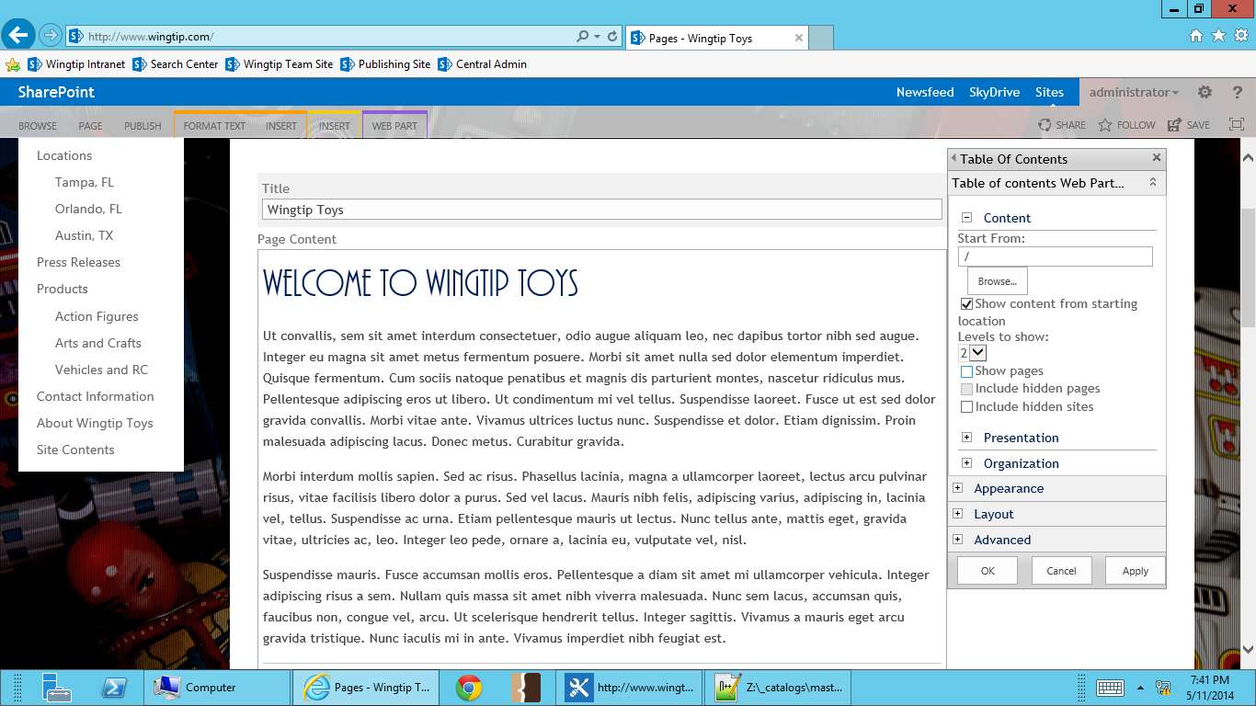

1. **Check in** you page. You’ll see that the only the sites are showing in the Table of Contents web part.

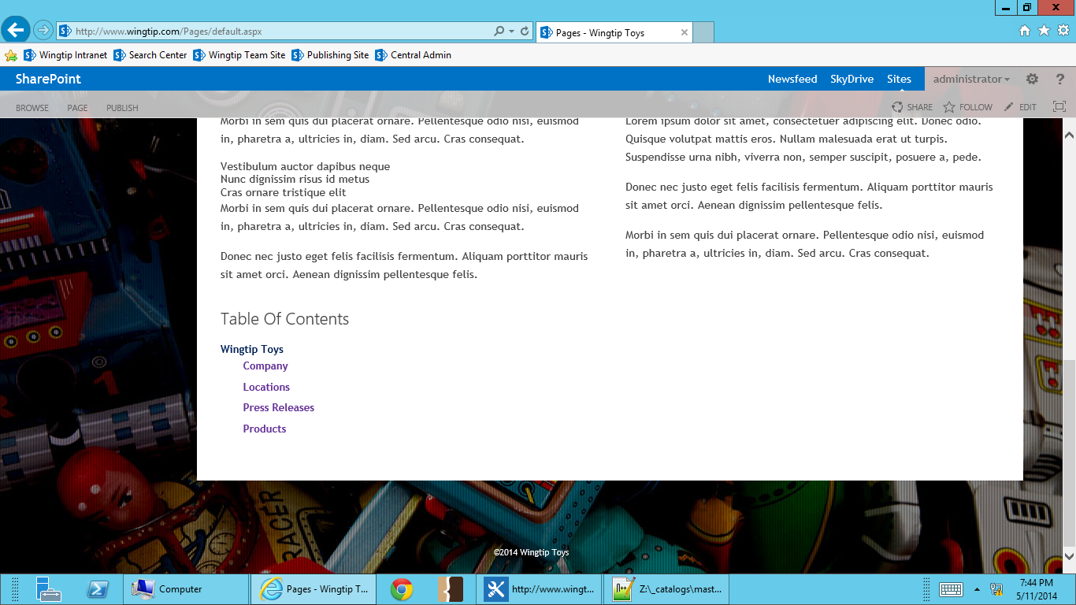

**In this lab you added a Web part to a publishing page and configured its properties.**

### Exercise 3: Working with the Content By Query (CBQ) Web Part

In this exercise you will use the Content By Query Web part to roll up pages from the news site.

1. Place the home page in **Edit** mode.
2. Locate the **Right** Web part zone and click **Add a Web Part**. In the **Categories** pane chose the **Content Rollup** folder. In the **Parts** pane chose the **Content Query** web part and click **Add**.
3. You should now see the **Content Query** Web part on the page.

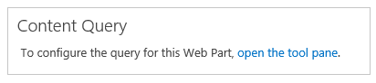

1. Click the **open the tool pane** text.
2. In the **Content Query Tool Part** pane expand the **Query** node.
3. Select **Show items from the following site** and click **Browse**. In the **Select Site** dialog choose the **Press Releases** site.

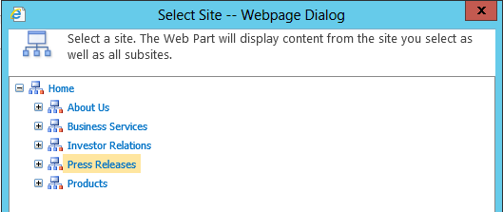

1. Click **OK** to close the dialog.
2. In the **Content Type** section change the **Show items of this content type group** to **Page Layout Content Types**.
3. Change the **Show Items of this content type** to **Article Page**.

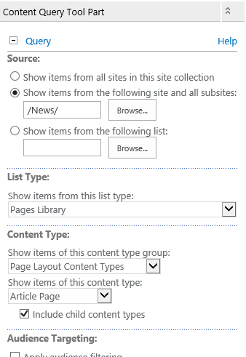

1. Expand the **Presentation** section and change the **Item style** to **Title and description**.
2. Click **OK** in the tool pane to save your changes. Your web part should now display Articles from the News site.

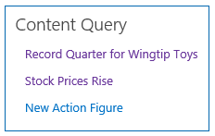

1. **Edit** the Web part and expand the **Presentation** section. Change the **Item style** to **Image on left**.
2. Expand the **Appearance** section and change the **Title** to **Latest News**.
3. Click **OK** to save the changes. **Save** the page, check it in and **publish** it. The Web part should look similar to the image below.

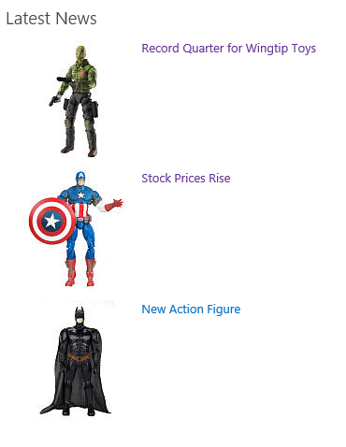

**In this lab you added a Content Query Web part to a page and change the query and display properties to use the out of the box styles. In the next lab you will learn how to create your own styles.**

### Exercise 4: Customizing Content By Query (CBQ) Web Part Output using XSLT

In this exercise you will learn how to add new Item Styles to the Content By Query Web part. The Content By Query Web part uses styles contained in the ItemStyles.xsl file in the site collection Style Library. This file can be edited with SharePoint Designer to add new styles for your web site. In this lab you will learn how.

1. Open **SharePoint Designer 2013**. Open the SharePoint site **[Publishing Site]** .
2. In the **Navigation pane** chose **All Files**.
3. Click into the **Style Library** and **XSL Style Sheets** folder.
4. Right click **ItemStyle.xsl** and choose **Edit in Advanced mode**. When prompted to check the file out choose **Yes**.

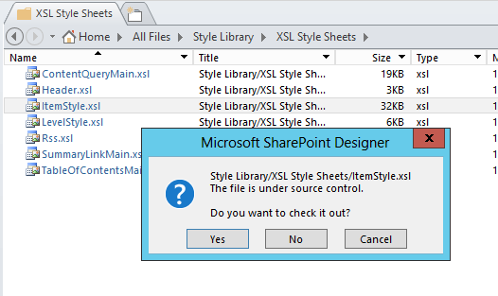

An XSL stylesheet is essentially like XML. The file translates XML into HTML. Each “template” in the file relates to one of the Item Styles in the Content Query Web part.

1. Open the file **[Lab Files]\NewsHeadlines.xsl**. Copy the entire file and paste the code just before the last tag **</xsl:stylesheet>** near the end of the file in SharePoint Designer.

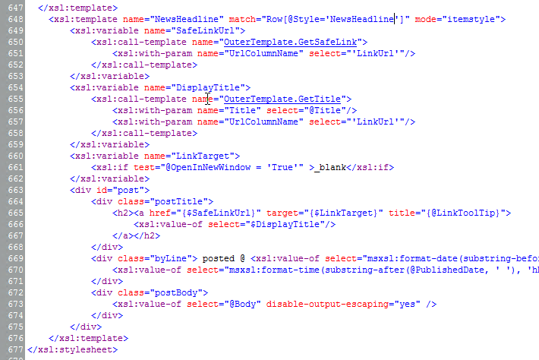

1. Click **Save**.
2. If you receive a **Site Definition Page Warning**, click **Yes**.

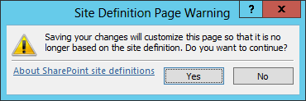

This one small change needs to be tested before we proceed. You test your changes by returning to the Content Query Web part and inspecting the Item Styles, your new “NewsHeadline” style should be present.

1. In the browser return the [Publishing Site] home page. Choose **Site Actions | Edit Page**.
2. On the **Content Query** Web part (now titled Latest News) click **Edit Web Part**.
3. Expand the **Presentation** section. Click the drop down for the **Item style** property and you should see the **NewsHeadline** as an option.

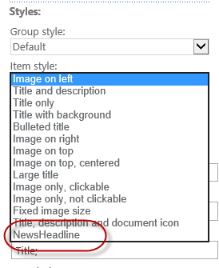

1. Select **NewsHeadline** and click **OK** to save your changes. The Web part may not look like you expected.

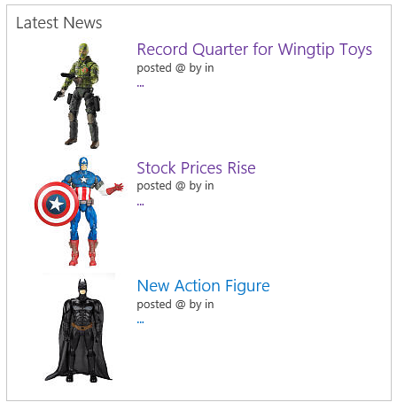

Notice that the fields referenced in the XSL file like **PublishedDate**, **Author, ByLine** and **Body** are not available to the Content Query Web Part by default. In order to add new fields you have to change the default field mapping. This is the magic of the Content Query Web part, now that you have added these fields the Web part will provide a place for you to map them. In the next section you will Edit the CBQ Web part and add the necessary mapping.

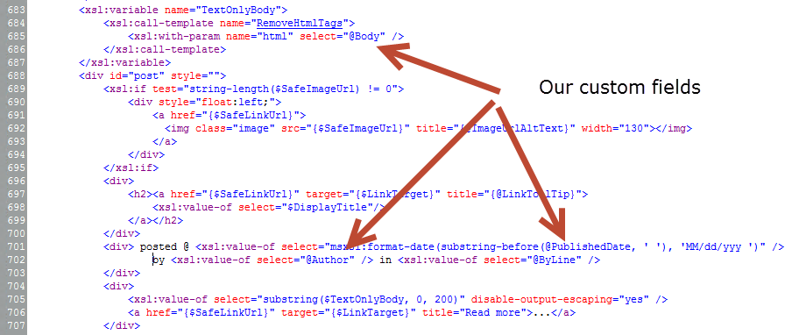

1. **Edit** the page again and **Edit** the **Latest News** Web part.
2. Expand the **Presentation** section and notice the new fields that are present in the **Fields to display section**. The Web part detected the new fields in the XSL Style and added them to the Web part…see…*magic*!
3. Add the following Article Page content fields to the web part (there is a semicolon at the end of each):
   1. PublishedDate: **Article Date;**
   2. Author: **Contact Name;**
   3. Byline: **Byline;**
   4. Body: **Page Content;**

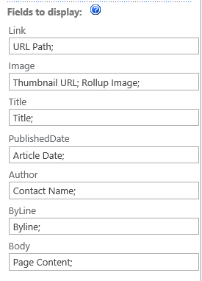

1. Click **OK** to save your changes.
2. Save the Page by clicking **Save** on the **Page** tab. **Check-in** and **Publish** the page.
3. Your finished Web part should look like this:

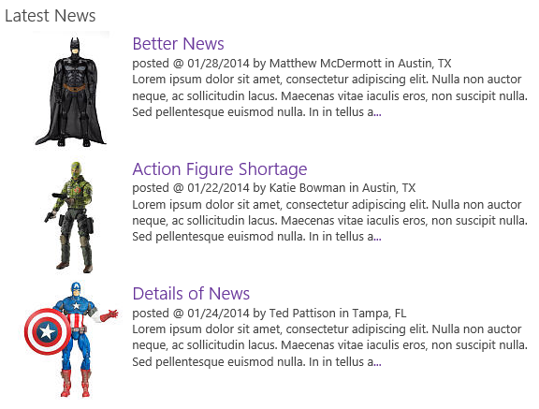

**In this lab you learned about the connection between the Content Query Web part and the associated ItemStyle.xsl file. You also added a custom item style with custom fields that enabled you to map fields from your Article content type to display a brand new content rollup for news items.**